**Character Research**

In this piece of research, I’m going to be researching potential character ideas for each of the four themes that I have previously researched.

**Theme #1: Beach**

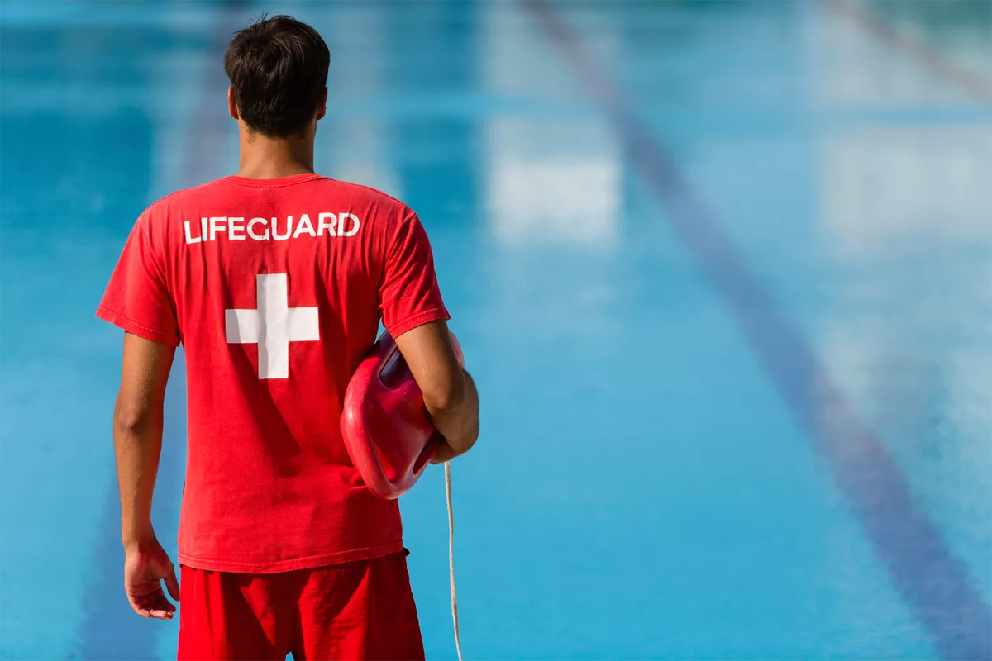

Idea #1: Lifeguard

For this idea, I’ve decided that look at the more heroic side of this theme. Lifeguards are the employed heroes of any beach; always helping with those struggling to swim or getting into a pinch. I feel a Lifeguard for this theme would make the player feel like they have more of a responsibility, and feel noble when playing this character in the beach theme.

Idea #2: Shark

For this idea, I’ve decided to look at the contrary. I’ve previously mentioned in the other document that sharks would make good enemies, however, I feel that they could also be interesting characters to play as. This would let the player feel a sense of empowerment, as they get to play a ferocious and fierce predator. The roles can instead be reversed, and instead opposing them would be the coastal guard, as they rampaged through the level.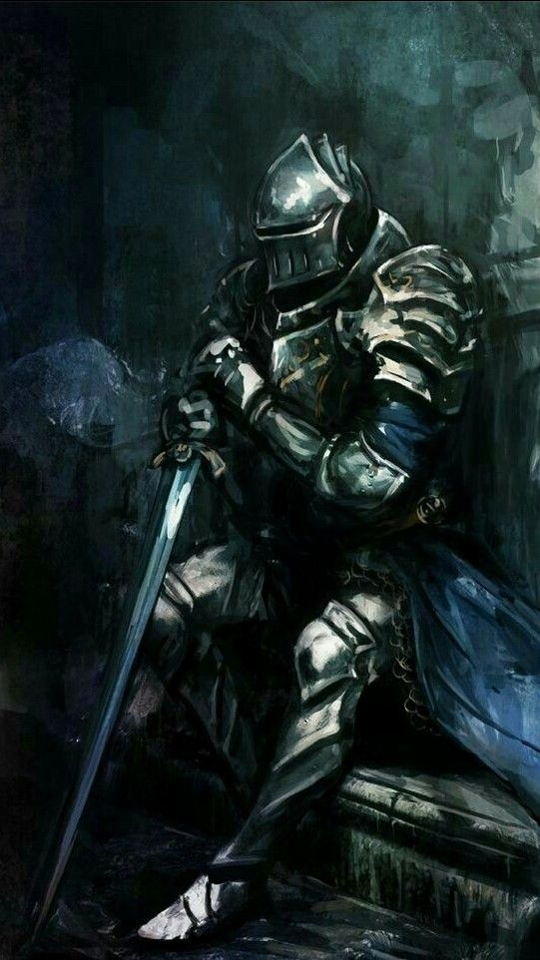

**Theme #2: Dungeon**

Idea #1: Knight

What could be one of the more cliché ideas on this list, a Knight would actually fit this theme surprisingly well. This particular theme is borrowed off of your typical fantasy novel or game where the knight must adventure the curious, and menacing depths of a dungeon in search of treasure or a damsel. I think by having the player play as a Knight, they will feel like the typical hero of the story.

Idea #2: Goblin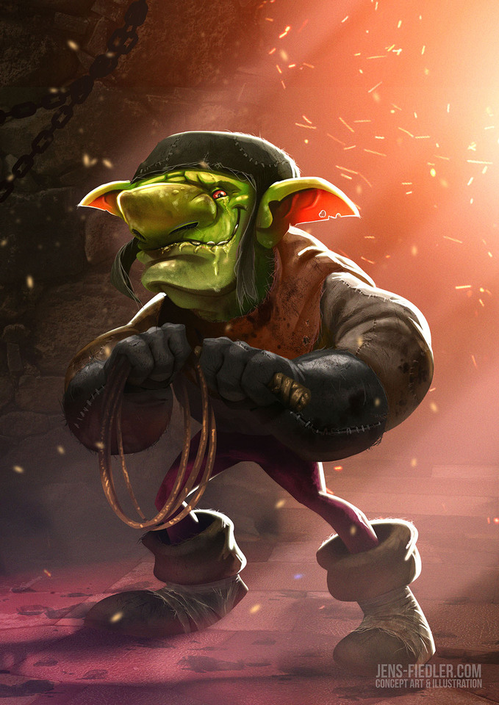

This idea is a bit different, and inspired by one of my previous ideas (the shark idea). I think by playing as a Goblin, there will be an interesting new dynamic that the player isn’t use to. People are always use to seeing these small, fantasy creatures as disposable, low level enemies. So I think the player will instead feel a little more vulnerable if they see that they’re playing this kind of character. If using this idea, I can definitely see some interesting extra mechanics that could be added (or removed): such as the ability to *attack*. By removing the player’s ability to hurt enemies, they will definitely need to be a lot more careful.

**Theme #3: Cityscape**



Idea #1: Construction Worker

When coming along with the idea for the cityscape, one of the ideas that I narrowed within the generally wide theme of ‘Cityscape’ was a construction site. I commented about an idea of a construction site worker trying to navigate through a construction site, filled with rabid seagulls. I think a construction site worker is quite a mundane, yet unusual pick for a hero character. The player certainly might find the game a little more lighthearted with this idea, but with such a crazy-strewn idea as this one that’s a given.

Idea #2: Adorable Bunny Skateboarder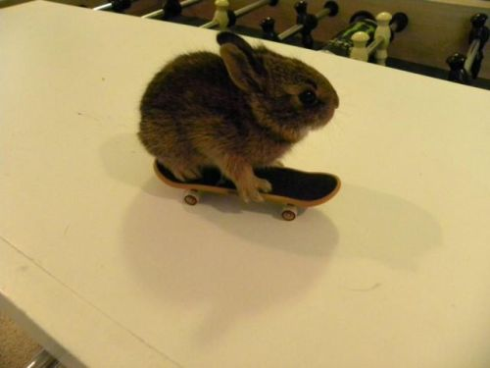

This idea is a completely out of the ballpark, and me personally going as crazy as possible. I initially wanted to consider something skateboard styley (something jet set radio-esque), where it’s a teenager skateboarding around the cityscape. However, I didn’t know how exactly the player would feel from that, so I decided to go with something that’s much easier to empathise with, a cute cuddly animal! I think the player will both simultaneously be confused, but enjoy the idea of playing as an adorable bunny on a skateboard.

**Theme #4: Space**

Idea #1: Astronaut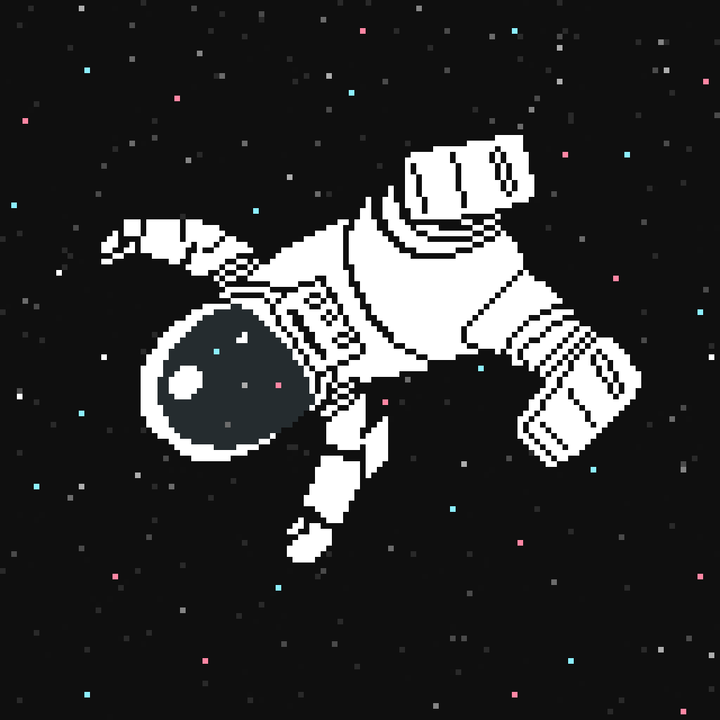

So a very clear idea to go along with the space theme (what I would consider the more rogue of the themes) would be an astronaut. It’s cohesive, simple, and makes for a more mysterious character. This idea is a straight shot idea that won’t allow the player to think much into it, and won’t exactly distract from the gameplay as something potentially more outlandish might.

Idea #2: Zombie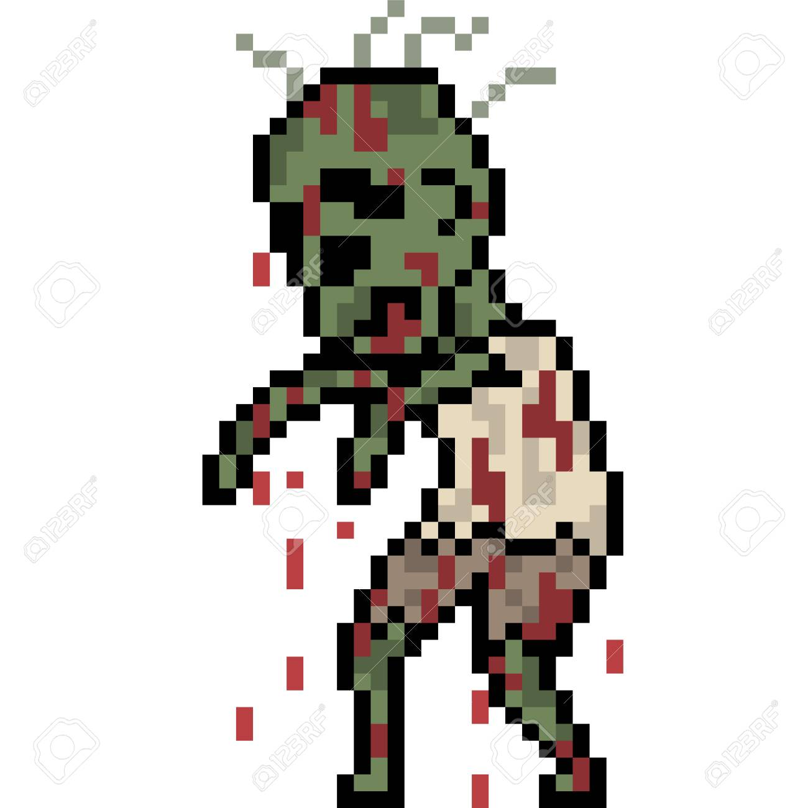

So, I ended my previous idea statement with not wanting to distract the player with something outlandish: so here I present the Zombie idea. I think this particular idea choice would intrigue the player, but I doubt that it’s something many people would really question. It’s an interesting mash of genres that could really add some colour to a space-themed game.